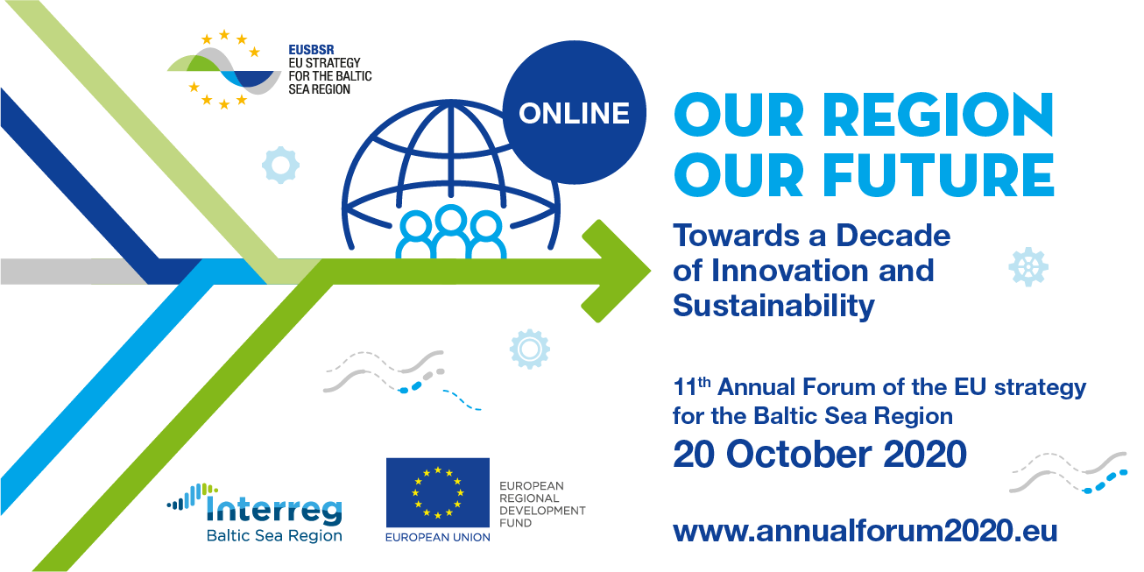

**Template for submitting the results of the workshop:**

|  |  |
| --- | --- |
| **Title of the workshop:** | Reducing security risks related to the climate change and mainstreaming climate agenda in EUSBSR after 2020 |
| **Organiser** | Council of the Baltic Sea States, Union of the Baltic Cities Sustainable Cities Commission |
| **Corresponding EUSBSR objective** | Save the Sea; Connect the Region; Increase Prosperity |
| **PAs and HAs involved** | HA Climate, PA Secure, HAàPA Spatial Planning |
| **Who was in the workshop (how cross-sectorial was it?)** | Local authorities, VASAB, UBC, CBSS, SEI Tallin, international and regional organisations working with climate issues. |
| **Challenge that was addressed (max 100 words)** | * How will climate adaptation and risk reduction agenda be integrated in the EUSBSR Action Plan?   There are several current climate change-related security risks that have been identified in the region. The Cascade Project is looking into these and looking for models, tools and recommendations, such as risk assessment methodologies focusing on climate change risks, tailor-made for the local level, and specifically for the BSR.   * Regarding the new EUSBSR Action Plan and Climate coordination:   + There should be a clear strategy on how climate related tasks will be organised and coordinated into the EUSBSR after 2020 until 2030. Particularly the sectors that work with climate actions, either directly or indirectly, such as Tourism, Safe and Education. |
| **Short summary of a solution or proposed steps in addressing the challenge (max 400 words)** | **Recommendations/solutions:**  The CASCADE project demonstrates, the importance of strengthen political and public support for DRR as well as improving the work in DDR by:   * Tailoring the Sendai Framework to the regional context and its challenges; * Strengthening multilevel and cross-sectoral cooperation to enable a common, coherent approach in disaster risk reduction and climate change adaptation; * Develop stronger coordination mechanisms for effective planning of implementation and cooperation as well as information exchange; * Increasing the systemic support from the national for local level planning; * Improving guidance and support (incl. financial);   Integrating climate adaptation across all policy areas and relevant sectors.  The EUSBSR Action Plan 2030, states that  climate change should be integrated in the management and coordination of each of the individual Policy Areas. Additionally, climate change adaption is a cross-cutting issue that should be integrated into different levels of cooperation (local/national/macro-regional) as well as in collaboration with the Sendai Framework, Agenda 2030 and the Sustainable Development Goals. Furthermore, cooperation on macro regional Climate Change issues can be strengthened by:   * Establishing strong leadership to approach the climate agenda holistically, using a common language, benchmarking performances and exchanging practices. * Utilising existing institutional capacity and forums to strengthen the climate agenda in the EUSBSR, in order to meet the EU climate policy goals. * Having a focal point that will be responsible for driving the climate agenda in the BSR and ensuring efficient facilitation of raising climate issues through different strategic instruments. * Building a consortium of regional organisations with relevant experience and stakeholder groups that would ensure proper implementation of climate objectives. |
| **Expected positive change if the proposed steps are taken (max 100 words)** | Improved resilience and preparedness nationally and on the Baltic Sea Region level.  Improved cooperation between national authorities and mainstreaming climate strategies in all Policy Areas by 2030. |
| **1-3 photos, drawings or infographics, illustrating the solution(s).** |  |
| **Important logos** |  |
| **Presentations** |  |