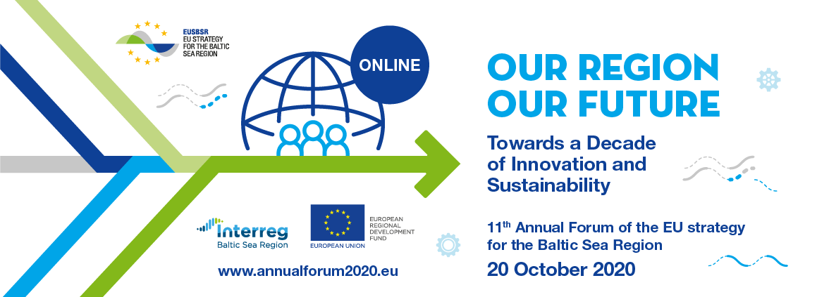

**Template for submitting the results of the workshop:**

|  |  |
| --- | --- |
| **Title of the workshop:** | **Innovation for Carbon Neutral Baltic Sea Region** |
| **Organizers** | HA Climate, PA Innovation, PA Transport, PA Energy |
| **Corresponding EUSBSR objective** | Saving the sea, connecting the region and increasing prosperity |
| **PAs and HAs involved** | HA Climate, PA Innovation, PA Transport, PA Energy |
| **Who was in the workshop (how cross-sectorial was it?)** | European Commission DG Energy, CBSS Secretariat, ministries of energy, economy, transport and environment from Sweden, Germany, Estonia, Latvia and Lithuania, All-European and national business associations, Universities and research institutes from Finland, Germany, Estonia; Pan-Baltic organizations Union of Baltic Cities, VASAB and Swedish Institute; INTERREG Baltic Sea and South-Baltic regions; TSO-s from Latvia, Estonia and Lithuania |
| **Challenge that was addressed (max 100 words)** | EU has already set out a clear vision of how to achieve climate neutrality by 2050. To deliver the European Green Deal, there is a need to rethink policies for clean energy supply across the economy, industry, production and consumption, large-scale infrastructure, transport, food and agriculture, construction, taxation and social benefits. Transport accounts for a quarter of the EU’s greenhouse gas emissions, and still growing. To achieve climate neutrality, a 90% reduction in transport emissions is needed by 2050. Besides other measures, there is need to ramp-up the production and deployment of sustainable alternative transport fuels. By 2025, about 1 million public recharging and refueling stations will be needed for the 13 million zero- and low-emission vehicles expected on European roads. In July 2020, the Commission presented the Hydrogen Strategy for climate-neutral Europe. The strategy will explore ways to strengthen the production and use of clean hydrogen, focusing on mainstreaming renewable hydrogen. PA Innovation, PA Transport, PA Energy and HA Climate will at joint seminar explore the status, barriers and opportunities to boost wider use of hydrogen as clean vehicle fuel and as energy storage required for wider deployment of large-scale offshore wind energy production in BSR. |
| **Short summary of proposed solution(s) (max 200 words)** | In order to achieve shift from fossil fuel based to carbon neutral economy in BSR by 2050, the workshop proposed following:  ● Rapidly expand the share of RE and offshore wind in the BSR countries (targets and incentives)  ● Create stable investment climate through strong H2  policy targets (eg: quotas)  ● Verify and certify the green origins & carbon footprint  of H2  ● Reduce fossil fuel subsidies towards a full phase-out  ● Implement higher CO2 prices to level playing field  ● Reduce fiscal and administrative burden on H2  (reducing or removing grid fees, surcharges or taxes)  ● Initiate Cross-sector exchange between industry, research and government  ● Facilitate regional /international cooperation and partnerships between countries  ● Support joint offshore wind and H2 (pilot) projects in the BSR |
| **Expected result(s) of the implementation of the solution (max 100 words)** | Better understanding on status, barriers, and opportunities of hydrogen use in transport and energy sectors in BSR. Recommendations for promoting hydrogen mobility and energy in BSR. |
| **Important Internet links: organisers, projects, workshop description and/or documents** | <http://haclimate.eu/about-us/library/>  <https://ec.europa.eu/energy/sites/ener/files/hydrogen_strategy.pdf>  <https://hydrogeneurope.eu/clean-hydrogen-europe>  <https://www.uudenmaanliitto.fi/en/projects/bsr_access_-_clean_efficient_and_multimodal_transport_corridors/project_library> |
| **1-3 photos, drawings or infographics, illustrating the solution.** |  |
| **Important logos** |  |
| **Presentations** |  |